**Linux Basic Command Lines**

**Homework**

* + Install Ubuntu Server 22.04 on your VirtualBox:
    - Name: **HM1_Yourname_YourClass**

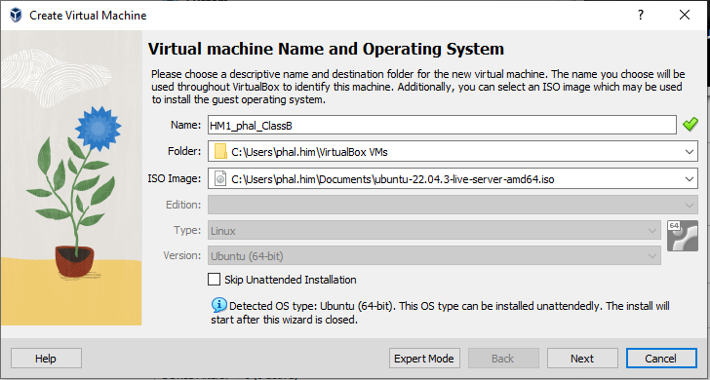

* + - RAM: 1GB or 2GB (depend on your computer performance)

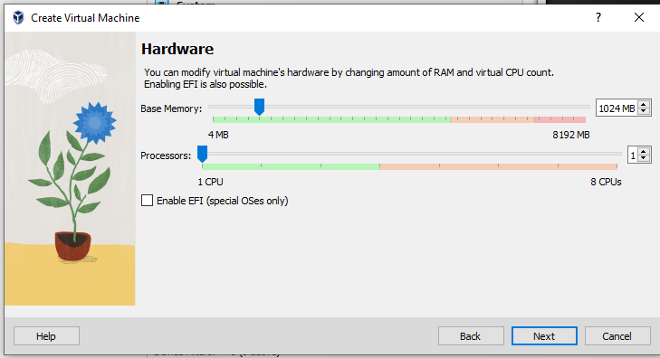

* + - HDD: 50GB

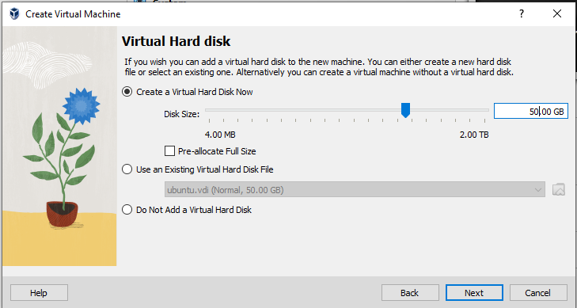

* + - Create user:
      * Username: **yourname**, password **123@pnc**

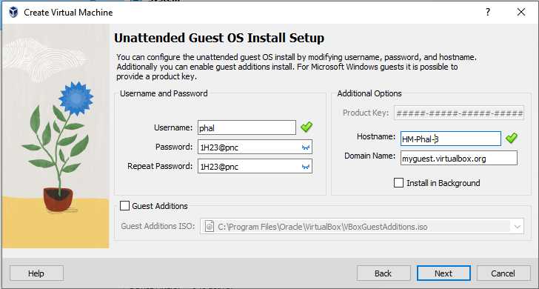

* + - PC’s name: **HM-yourname**

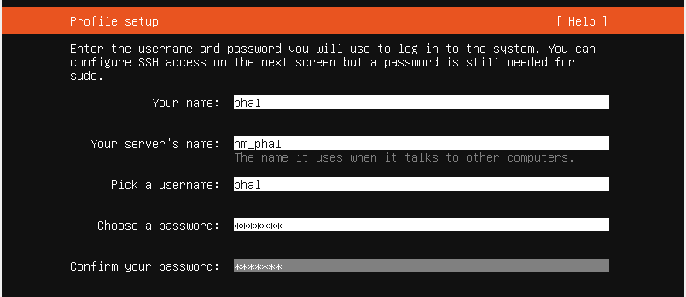

* + - After installation complete, login to your server and assign password to user Root **root@linux**

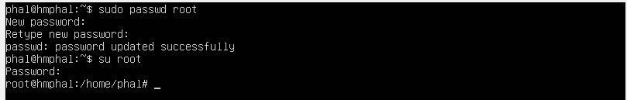

* + - Check IP address on server and ping to 8.8.8.8 to check Internet connection.

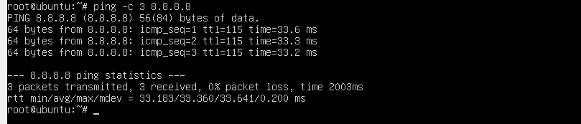

* + Install packages:
    - Apt update and upgrade your system software

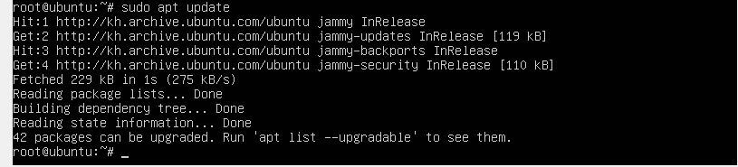

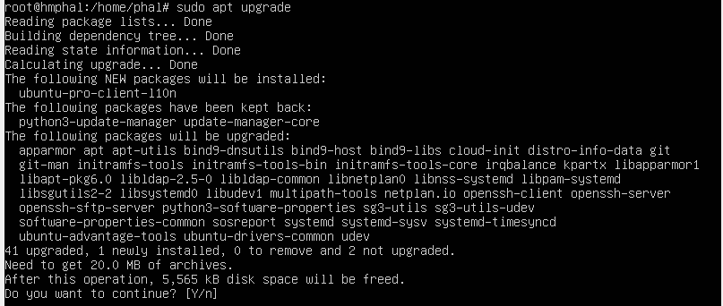

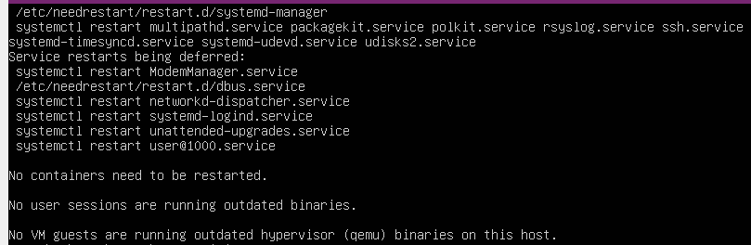

* + - 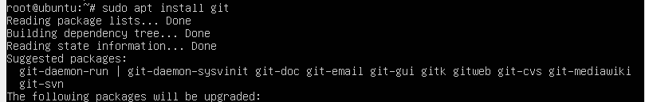Install package **git**, **nodejs**, and **npm** in Ubuntu server

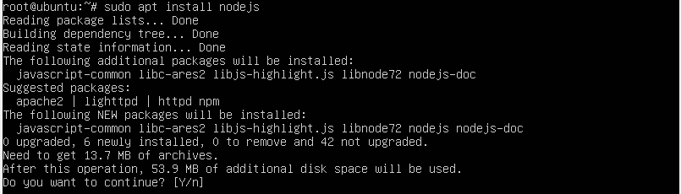

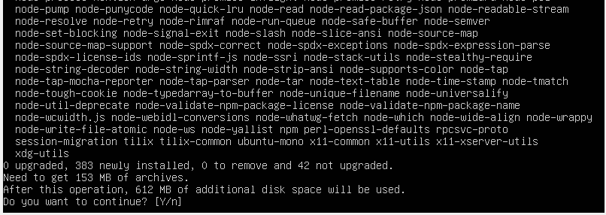

* + - Use command that check if all package are installed

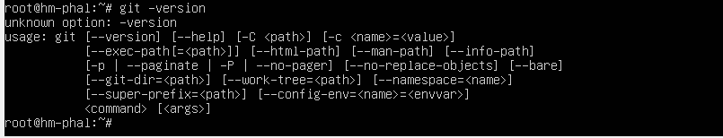

* + - Use apt command to remove git from server

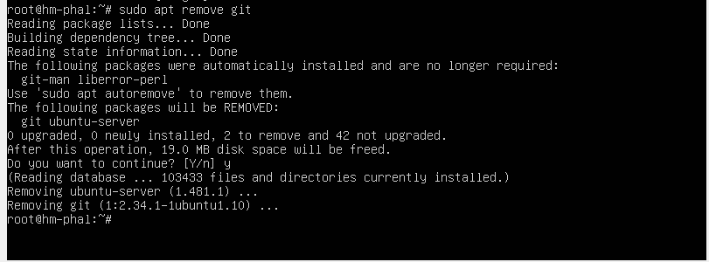

* + Basic Command Lines:
    - Create directories and files according to the given topology:

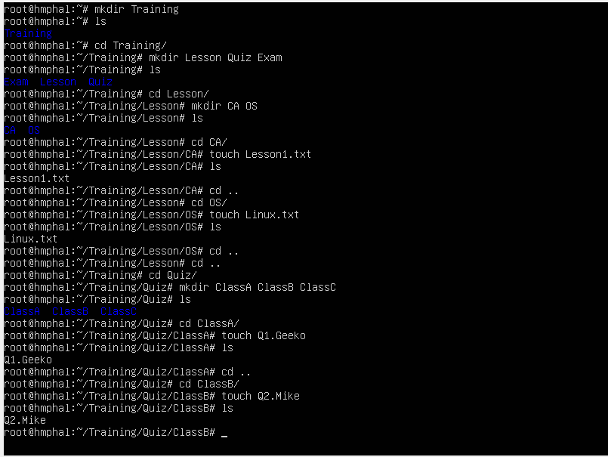 Lesson 
ClassA 
QI.Geeko 
/Traini 
Quiz 
ClassB 
Q2.Mike 
lassC 
Q3.John 
idter 
os 
Exam 
Final 
os 
Lessonl.txt 
os 
Linux.txt 

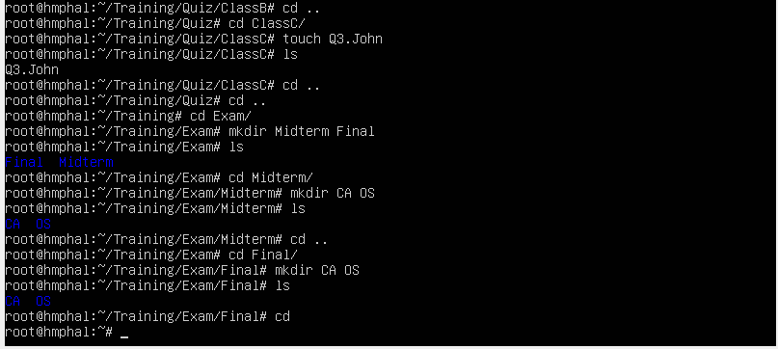

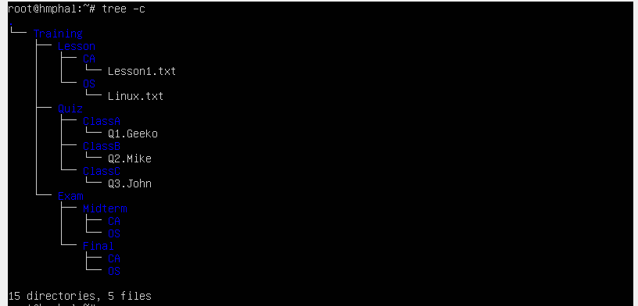

* + Insert text **"**I love homework! I wish to have homework every day. I will do my best to complete all my homework. I will ask my friends or teach to explain if I don't understand. I will do all my best!**"** into file ***lesson1.txt*** then copy it to paste in **/Training/Exam/Midterm/CA**

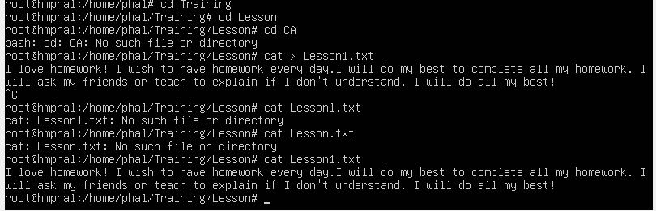

* + Rename file "Linux.txt" to "yourname.txt" then move it to **/Training/Exam/Final/OS/**
  + 
  + 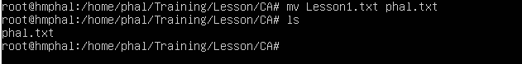Use **Cat** command to view both files **Lesson1.txt** and **yourname.txt**
  + Copy file from **/etc/passwd** to paste in **/Training/lesson/OS/**
    - Use **less** command to view content within file passwd and search the word "**mail**" in the file
    - Use **grep** command to search word "**root**" within file passwd
    - Use **cut** command to display only to **1st** and **5th field** of all lines within file passwd
  + **Remove files** Q1.Geeko , Q2.Mike and Q3.John

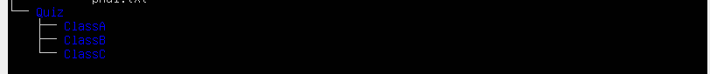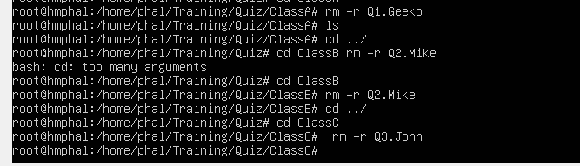

* + 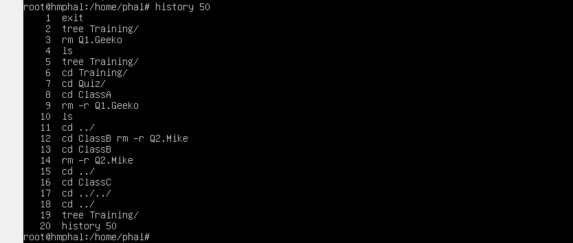Show all histories of your commands but only the **last 50 lines**
  + 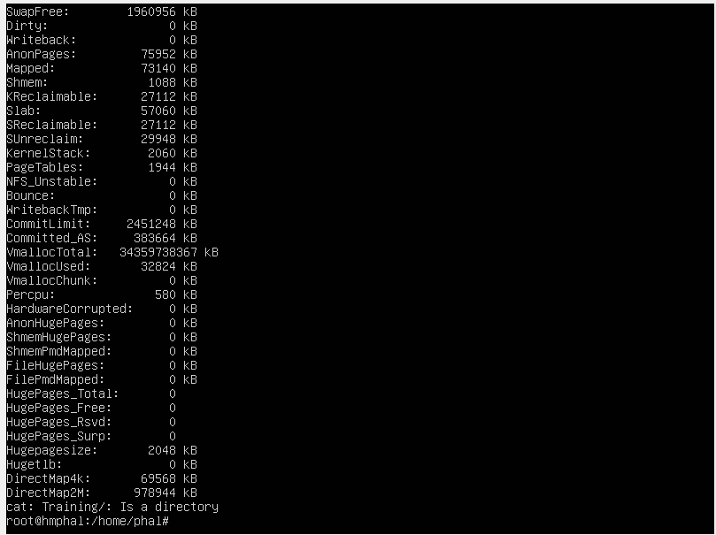Use command line to show your system's **memory usage**
  + 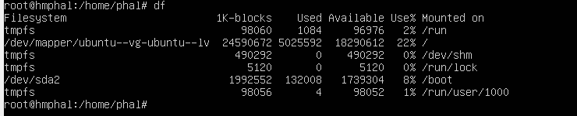Use command line to show used and available **disk space** on your system
  + Create a normal user name “**geeko**” with password **12345**
    - Verify by checking geeko’s *home directory* in */home*
  + Use command “grep” to search word “geeko” inside file /etc/passwd.
  + **Login** again to your system by using user geeko

**Note** ****************

* + - You need to show all the result for what you already created or configure by the following tasks.
    - **Example**: ues **ls -l** or **ll** command to view folders or files that you were created.
    - **Print screen** all your result then creates one **word document** file to put all those result
    - Please be **well-organize** of your document file
    - Submit your result back into **classroom**, deadline **Tuesday, 13th Dec 2023**

